Title
GLOBEXA – AI-Powered Travel Planning and Management System

1. Introduction
The travel and tourism industry has experienced rapid digital transformation in recent years, with travelers expecting seamless, personalized, and convenient travel planning solutions. However, many existing travel platforms operate in a fragmented manner, requiring users to depend on multiple applications or services for destination search, hotel booking, transportation arrangements, and payment processing. This fragmented approach increases planning complexity, consumes time, and often fails to provide a unified and personalized travel experience.
To address these challenges, GLOBEXA is proposed as an integrated, AI-powered travel planning and management system. The platform combines destination exploration, customized travel packages, hotel and taxi booking, secure online payments, and travel experience management within a single application. By leveraging modern web technologies, cloud-based data storage, and artificial intelligence, GLOBEXA simplifies travel planning and enhances user engagement. The system acts as a smart digital travel companion, offering a smooth and personalized experience across both web and mobile platforms.

2. Existing System / Literature Review

Existing System
The existing travel planning systems are mostly distributed across multiple platforms such as hotel booking websites, taxi booking applications, travel blogs, and payment gateways. Users must manually compare prices, availability, and services across different platforms. Most of these systems provide limited personalization and do not adapt recommendations based on user preferences, travel history, or real-time data.

Limitations of Existing System
- Fragmented travel planning across multiple platforms
- Lack of personalized travel recommendations
- Time-consuming and complex booking process
- Limited integration between services
- Poor user experience and coordination

Literature Review
Recent research in the travel technology domain highlights the importance of integrated platforms and artificial intelligence in enhancing user experience. AI-based recommendation systems are increasingly used to analyze user preferences, travel behavior, and market trends to suggest personalized travel options. Studies indicate that AI-powered travel platforms improve planning efficiency, user satisfaction, and decision-making accuracy by providing unified and intelligent travel solutions.

3. Objective of the Proposed System
The main objectives of the GLOBEXA system are:
- To provide an integrated platform for complete travel planning and management
- To offer personalized travel recommendations using artificial intelligence
- To enable destination exploration and customized travel packages
- To support hotel booking, taxi booking, and secure online payments
- To reduce travel planning complexity and save user time
- To enhance user experience through a unified and intelligent travel system

4. System Architecture Diagram

System Architecture Description
The GLOBEXA system follows a client–server architecture consisting of the following components:
- User Interface (Frontend)
  - Accessible through web and mobile browsers
  - Allows users to search destinations, book hotels and taxis, and manage travel plans
  - Displays personalized recommendations and travel details
- Application Server (Backend)
  - Handles user requests, authentication, and business logic
  - Processes booking, payment, and travel management operations
- AI Recommendation Engine
  - Analyzes user preferences, travel history, and input data
  - Generates personalized travel packages and recommendations
- Database & Cloud Storage
  - Stores user profiles, bookings, payments, and travel data
  - Ensures secure and efficient data management

Architecture Flow
- User interacts with the frontend interface
- Requests are processed by the backend server
- AI engine generates recommendations based on user data
- Data is stored and retrieved from the database
- Results are displayed back to the user
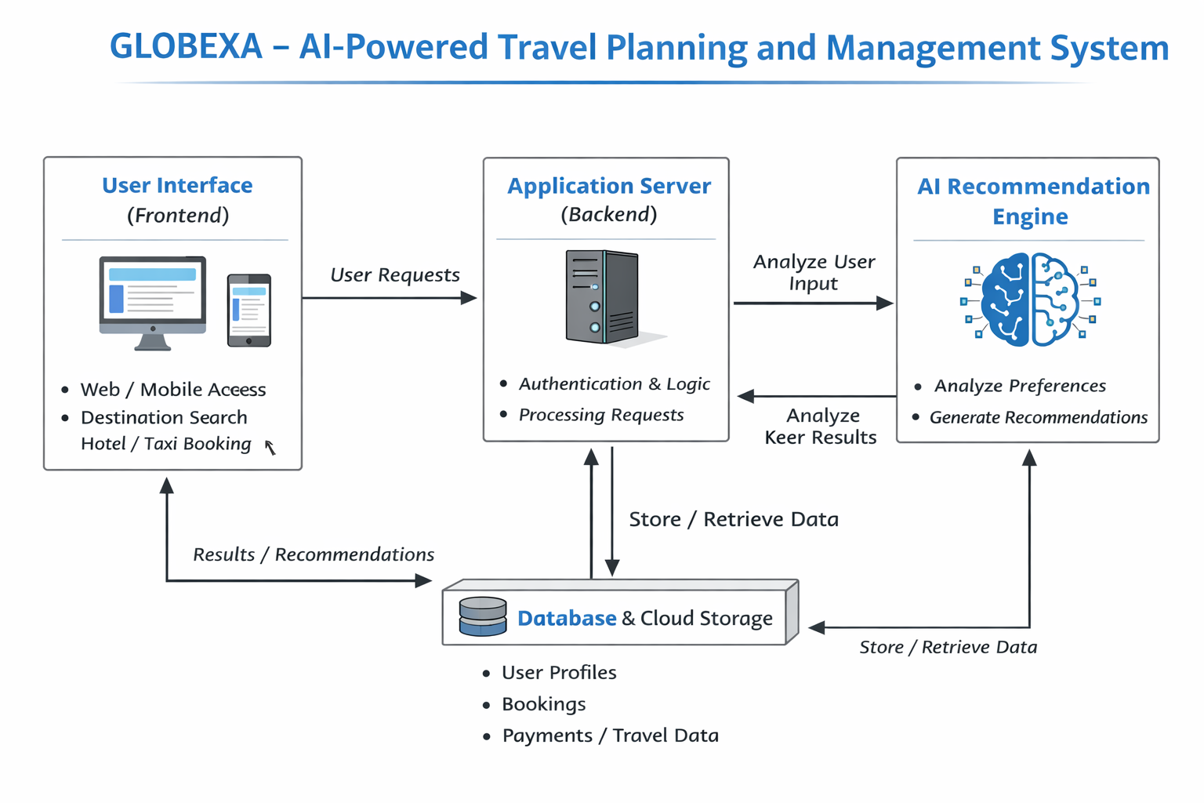

Conclusion
GLOBEXA provides a modern, intelligent, and integrated solution for travel planning and management. By combining artificial intelligence with unified travel services, the system simplifies complex travel processes and enhances user satisfaction. The platform supports efficient planning, personalized experiences, and seamless travel management, making it a valuable digital solution in the evolving travel and tourism industry.

